Name_________________________

Psych Stats - PSY 3024 | Spring 2012 | Brannick | Exam 2

Instructions: Write your name and U number on the scantron. Answer any 40 of 45 questions on the exam by bubbling in the best of the four alternatives given. For those questions you wish to omit, bubble in “e.” If you answer all 45, I will choose the last 5 for you, so it is in your interest to pick 5 and bubble in “e”. You can take the printed exam with you. Give the scantron to your lab instructor (or proctor) when you are done.

Handy formulas:
$$σ_{\bar{X}}=\frac{σ_{X}}{\sqrt{N}}$$ | $s_{\bar{X}}=\sqrt{\frac{s_{X}^{2}}{N}}$;$s_{X}^{2}=\frac{\sum{(X−\bar{X})^{2}}}{N−1}$
$$z=\frac{\bar{X}−μ}{σ_{\bar{X}}}$$ | $$t_{\text{obt}}=\frac{\bar{X}−μ}{s_{\bar{X}}}$$
$$\text{95}\text{\%}\text{CI}=\bar{X}±z_{\text{.}\text{05}}σ_{\bar{X}}$$ | $$\text{95}\text{\%}\text{CI}=\bar{X}±t_{\text{.}\text{05}}s_{\bar{X}}$$
$r=\frac{\sum{z_{X}z_{Y}}}{N}$; $z_{X}=\frac{X−\bar{X}}{S_{X}}$ | $b=r\frac{S_{Y}}{S_{X}}$; $a=\bar{Y}−b\bar{X}$; $Y^{'}=a+\text{bX}$

Tabled values of z, the unit normal.
Z | Between mean and z | Beyond z |  | Z | Between mean and z | Beyond z
0.00 | 0.0 | 50.00 |  | 0.90 | 31.5 | 18.41
0.10 | 3.98 | 46.02 |  | 1.00 | 34.13 | 15.87
0.20 | 7.93 | 42.07 |  | 1.10 | 36.43 | 13.57
0.30 | 11.79 | 38.21 |  | 1.20 | 38.49 | 11.51
0.40 | 15.54 | 34.46 |  | 1.30 | 40.32 | 09.68
0.50 | 19.15 | 30.85 |  | 1.40 | 41.92 | 08.08
0.60 | 22.57 | 27.43 |  | 1.50 | 43.32 | 06.68
0.70 | 25.80 | 24.20 |  | 1.60 | 44.52 | 05.48
0.80 | 28.81 | 21.19 |  | 1.65 | 45.00 | 05.00
 |  |  |  | 1.70 | 45.54 | 04.46
 |  |  |  | 1.96 | 97.50 | 02.50

Critical values of t, alpha = .05, two-tails
df | t | df | t
1 | 12.706 | 6 | 2.447
2 | 4.303 | 7 | 2.365
3 | 3.182 | 8 | 2.306
4 | 2.776 | 9 | 2.262
5 | 2.571 | 10 | 2.228

Chapter 7 Correlation

- The correlation coefficient summarizes the relations between variables shown in a
  - bar chart
  - histogram
  - pie chart
  - scatterplot

- Suppose we compute the correlation between X and Y and find the result to be .70, and the result is statistically significant. What can we conclude about the relations between the two?
  - There is an association between X and Y
  - There is no meaningful relation in the population
  - X causes Y
  - Y causes X

- Suppose we find that a correlation is positive and significant. When X increases, what do we expect to find on average for Y?
  - Cannot tell from information given
  - Y decreases
  - Y increases
  - Y remains constant

- The interpretation of a correlation of zero is that there is __________.
  - An error in computation
  - An inverse relation between X and Y
  - Curvilinear relations between X and Y
  - No linear relation between X and Y

- The definitional formula for the Pearson correlation is
  - $$b=r\frac{S_{Y}}{S_{X}}$$
  - $$r=\frac{\sum{z_{X}z_{Y}}}{N}$$
  - $$a=\bar{Y}−b\bar{X}$$
  - $$z_{X}=\frac{X−\bar{X}}{S_{X}}$$

- Restricting the range of X or Y scores leads to an ___________ estimate of the true strength of the relationship between variables.
  - Accurate
  - Incalculable
  - Over-
  - Under-

- Many colleges use high school grade point averages as part of their admissions process. If such colleges were to compute the correlation between high school GPA and the GPA for the admitted students after their freshman year of college, what would the college expect to see?
  - Negative correlation
  - Positive correlation
  - Spearman correlation
  - Zero correlation

- Consider the four following graphs. Which shows the most negative correlation?
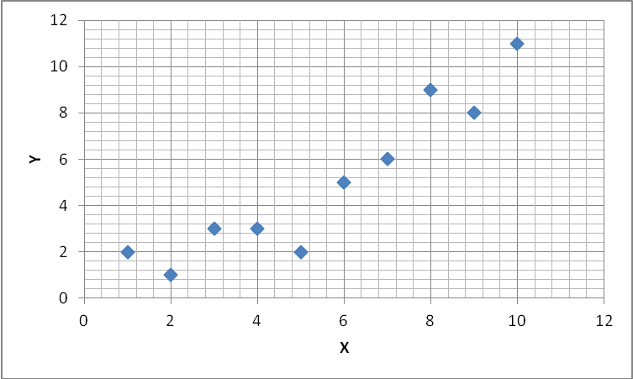 | 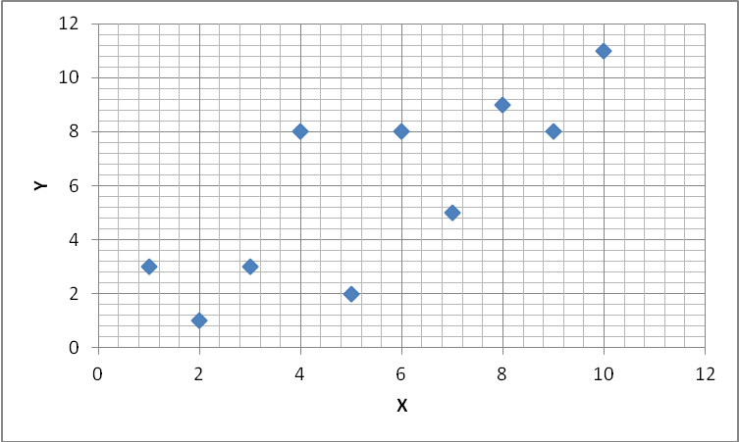 | 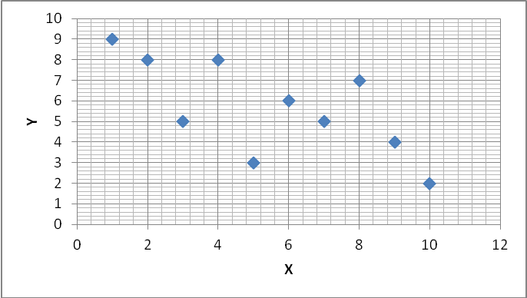 | 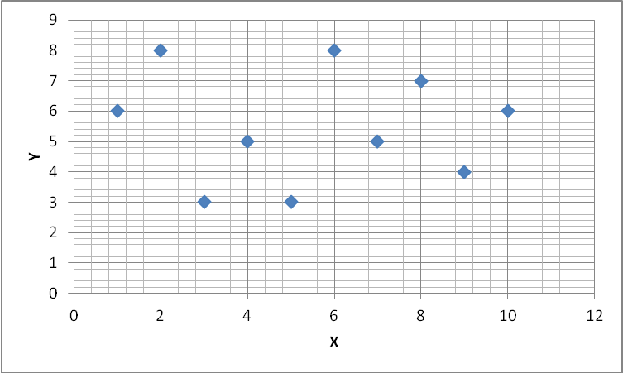
A | B | C | D

  - A
  - B
  - C
  - D

Chapter 8 Regression

- The place on the regression line where X=0 is called the _______.
  - intercept
  - linear
  - origin
  - slope

- Changing the value of b on the regression line changes the _____ of the line.
  - Deviance
  - Intercept
  - R-square
  - Slope

- Suppose the mean of X is 10, the mean of Y is 5, the slope is 1. What is the value of the intercept?
  - -5
  - 0
  - 5
  - 10

- A psychologist studying the relationship between stress and illness has developed a stress scale that has a mean of 50 and a standard deviation of 10 (T-scores). After studying 500 people for a year, she determined that the regression equation relating yearly doctor visits to the scores on the stress scale showed a slope of .1 and an intercept of -1. Jane scored 50 on the stress scale. How many doctor visits is Jane expected to have in the next year?
  - -1
  - 4
  - 5
  - 50

- One of the main differences between correlation and regression is that regression is used to ______.
  - Determine causality
  - Indicate degree of association
  - Predict values of Y
  - Summarize a scatterplot

A researcher gathered data from husbands and wives. In the printouts and graph below, the husband’s height is indicated by height in centimeters, and the wife’s is indicated as spouse’s height in centimeters.

Correlations
 |  | HEIGHT (CMS) | SPOUSES HEIGHT (CMS)
HEIGHT (CMS) | Pearson Correlation | 1 | .303**
HEIGHT (CMS) | Sig. (2-tailed) |  | .000
HEIGHT (CMS) | N | 4774 | 3161
SPOUSES HEIGHT (CMS) | Pearson Correlation | .303** | 1
SPOUSES HEIGHT (CMS) | Sig. (2-tailed) | .000
SPOUSES HEIGHT (CMS) | N | 3161 | 3163
**. Correlation is significant at the 0.01 level (2-tailed).

Coefficientsª
Model |  | Unstandardized Coefficients |  | Standardized Coefficients | T | Sig.
 |  | B | Std. Error | Beta | T | Sig.
1 | (Constant) | 113.677 | 2.615 |  | 43.470 | .000
1 | HEIGHT (CMS) | .269 | .015 | .303 | 17.868 | .000
a. Dependent Variable: SPOUSES HEIGHT (CMS)

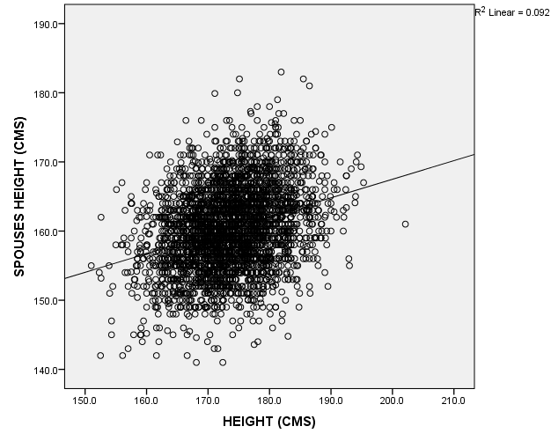
- How many pairs of husbands and wives both gave height data (what is N for the analysis)?
  - 303
  - 3161
  - 3163
  - 4774

- What is the correlation between husbands’ and wives’ height in centimeters?
  - .000
  - .269
  - .303
  - 1

- If the chosen husband’s height increases by 1 centimeter, how many centimeters taller is the wife expected to be?
  - 0
  - .269
  - .303
  - 1

- What is the value of the intercept for the husband and wife height data?
  - .269
  - 17.87
  - 43.37
  - 113.68

- In regression analysis, the value of $Y−Y^{'}$indicates the magnitude of the _______.
  - alienation
  - determination
  - error
  - prediction

Chapter 9 Probability

- Probability is defined to be
  - Absolute frequency in the population
  - Ratio of events of interest to events not of interest
  - Relative frequency in the population
  - Relative frequency in the sample

- If we draw a number at random from the unit normal distribution, what is the probability that the number will be larger than 1.0?
  - .16
  - .25
  - .50
  - .84

- With a normal distribution, $μ=\text{500}$, , and N=25, what is the probability of selecting an $\bar{X}$above 530?
  - .000
  - .07
  - .23
  - 1

- For the above problem ($μ=\text{500}$, , and N=25), what is the standard error of the mean?
  - 2
  - 8
  - 10
  - 20

- What is a rejection region?
  - A place in the sampling distribution near the mean
  - A place in the sampling distribution remote from the critical value
  - A place in the sampling distribution that is unlikely for a given population
  - An area of the curve that cannot exist under the assumptions of the model

- A sampling distribution is a distribution of a(n) ________ over all possible samples of size N.
  - alternative
  - critical value
  - hypothesis
  - statistic

- Significance testing lets us make decisions about _______ from ______ data.
  - Facts, opinions
  - Populations, sample
  - Treatments, population
  - Treatments, skimpy

- What happens to the standard error of the mean as the sample size increases?
  - Cannot tell; depends upon information not given
  - Standard error gets larger
  - Standard error gets smaller
  - Standard error stays the same

- If the mean of the sampling distribution equals the parameter, the statistic is said to be ________ .
  - accurate
  - biased
  - representative
  - unbiased

Chapter 10 Hypothesis Testing

- A psychological test of curiosity is has been developed (normed) so that the mean is 50 and the standard deviation is 10 for adults in the U.S. A researcher wants to know whether college students on average at a particular school are more or less curious than the average adult, so he samples 100 students from that school at random and gives them the curiosity test. What is the null hypothesis for this study?
- $H_{0}:μ=\text{50}$
- $$H_{0}:μ≠\text{50}$$
- $H_{0}:μ>\text{50}$
  - $H_{0}:μ<\text{50}$

- For the curiosity study above, what is the most likely alternative hypothesis?
  - $$H_{a}:μ=\text{50}$$
  - $$H_{a}:μ≠\text{50}$$
  - $$H_{a}:μ>\text{50}$$
  - $$H_{a}:μ<\text{50}$$

- How can we tell whether the rejection region should be split into two tails or concentrated into one?
  - Whether the alternative hypothesis is directional
  - Whether the null hypothesis is directional
  - Whether the statistic is biased
  - Whether the Type I or Type II errors are judged more important

- The $μ$for women on a test of empathy is 75 (high numbers mean more empathy). We test a sample of men to see if they are less empathetic than are women. What is the null hypothesis?
  - $$μ=\text{75}$$
  - $$μ≠\text{75}$$
  - $$μ>\text{75}$$
  - $$μ<\text{75}$$

- Suppose we try out a new method of teaching the t-test in intro stats. On the basis of our randomized trial, we determine that there is a statistically significant difference, so our new teaching method is effective. But further suppose that we have made a mistake, and that the truth is that our method is not effective, but we just got lucky in our trial. What kind of error will we have made?
  - Type A error
  - Type B error
  - Type I error
  - Type II error

- When computing a statistical test, the critical value of the statistic comes from
  - A tabled value
  - Statistical convention for a particular field
  - The experimenter who sets the criterion
  - The sample

- Suppose we run a randomized clinical trial for a new allergy pill. Our pill is supposed to reduce respiratory problems for people with pollen allergies. Further suppose that our study fails to find a significant result, even though the pill really is effective. What kind of error have we made?
  - Type A error
  - Type B error
  - Type I error
  - Type II error

- Facebook has determined that its population of registered users posts an average of 12 items per week ($σ$ = 3). They randomly sample 100 people and target them with updates and tidbits of information about their friends using snail mail postcards. Those people receiving postcards for a month averaged 13 online posts a week. Facebook wants to know whether the postcard produced a significant difference in online posting rates. What is the null hypothesis for this study?
  - $$H_{0}:μ=\text{12}$$
  - $$H_{0}:μ=\text{13}$$
  - $$H_{0}:μ>\text{12}$$
  - $$H_{0}:μ>\text{13}$$

- For the Facebook problem, what is the standard error of the mean?
  - .3
  - 3
  - 10
  - 12

- For the Facebook problem, if we assume a two tailed test, approximately where are the rejection region(s)?
  - 12.45
  - 11.33 and 12.66
  - 9 and 15
  - 6 and 18

- Given the result for Facebook, what can we say about the postcard plan (assume the population SD is known)?
  - The result was not significant, the postcard does not appear to online increase posting
  - The result was significant; the postcard appears to increase online posting
  - There was a correct rejection of the null hypothesis
  - There was a Type I error

Chapter 11 Hypothesis Testing Using the One-Sample t-Test

- How are the theoretical distributions of t and z related?
  - t approaches z as the sample size increases
  - They are the same once sample size is determined
  - z is thicker in the tails than is t
  - z takes uncertainty about the population variance into account but t does not

- In order to find the critical value of t in the table, you need to know alpha, tails, and _____.
  - Beta
  - Degrees of freedom
  - The null hypothesis
  - The population standard deviation

- Suppose you sample 10 finishers at random from a 5K race and measure the time to finish for each. You find $\bar{X}$=20 minutes and $S_{X}$=2 minutes and want to place a 95 percent confidence interval about that mean. What value of t should you use in your computation?
  - 1.650
  - 1.960
  - 2.228
  - 2.262

- Suppose that for the 5K race above, the null hypothesis stated that the average time would be 19 minutes. What would your obtained value of t be?
  - (19-20)*(2/$\sqrt{\text{10}}$)
  - (20-19)/ $\sqrt{\text{10}}$
  - (20-19)/(2/$\sqrt{\text{10}}$)
  - 2.228*(20-19)/(2/$\sqrt{\text{10}}$)

- What is the population symbol for the correlation coefficient?
  - r
  - $$ρ$$
  - $$α$$
  - $$β$$

- We tend to use the t-test instead of the z test in situations where we do not know the value of _____.
  - $$σ^{2}$$
  - $$μ$$
  - $$μ^{2}$$
  - $$α$$

- We want statistical tests with maximum power in order to improve_________.
  - Alpha
  - Correct rejections of the null hypothesis
  - False alarms
  - Type I error rate

